**PERTEMUAN 4**

**Laporan Praktikum - Source Code**

**NAMA : NOVIAN TRY HARTANTO**

**NPM : 4511210017**

**Source Code**

mvn archetype:create -DgroupId=com.p2.jdbc -DartifactId=belajar-jdbc

package com.p2.jdbc.latihan;

import java.sql.Connection;

import java.sql.DriverManager;

import java.sql.PreparedStatement;

import java.sql.SQLException;

import java.util.logging.Level;

import java.util.logging.Logger;

import java.math.BigDecimal;

public class Main

{

public static void main( String[] args )

{

try{

//paramenter yang dikirim adalah host,port , nama database ,user,password

Connection conn = DriverManager.getConnection("jdbc:mysql://localhost:3306/p2","root","");

String query = "INSERT INTO produk(nama,harga) values (?,"+new BigDecimal(23000)+")";

PreparedStatement ps = conn.prepareStatement(query);

ps.setString(1,"lala");

ps.executeUpdate();

}catch(SQLException se){

Logger.getLogger(Main.class.getName()).log(Level.SEVERE,null,se);

}

}

}

package com.p2.jdbc.latihan;

import java.sql.*;

import java.util.logging.Level;

import java.util.logging.Logger;

import java.math.BigDecimal;

import javax.swing.*;

public class Update

{

public static void main( String[] args )

{

try{

//paramenter yang dikirim adalah host,port , nama database ,user,password

Connection conn = DriverManager.getConnection("jdbc:mysql://localhost:3306/p2","root","");

Statement atm = conn.createStatement();

String query = "UPDATE produk set nama='dipsi' ,harga='4500' WHERE nama='lala'";

int hasil = atm.executeUpdate(query);

if(hasil == 1){

JOptionPane.showMessageDialog(null,"berhasil update");

}

else{

JOptionPane.showMessageDialog(null,"gagal update");

}

}catch(SQLException se){

Logger.getLogger(Main.class.getName()).log(Level.SEVERE,null,se);

}

}

}

mvn exec:java -Dexec.mainClass=com.p2.jdbc.latihan.Update

create table create table pembelian(

id_brg int PRIMARY KEY,

nama_brg varchar(20) ,

jumlah_brg int,

tgl_beli date,

ket text,

berat_brg decimal );

package com.p2.jdbc.soal;

import java.sql.Connection;

import java.sql.DriverManager;

import java.sql.PreparedStatement;

import java.sql.SQLException;

import java.util.logging.Level;

import java.util.logging.Logger;

import java.math.BigDecimal;

public class Insert

{

public static void main( String[] args )

{

try{

//paramenter yang dikirim adalah host,port , nama database ,user,password

Connection conn = DriverManager.getConnection("jdbc:mysql://localhost:3306/p2","root","");

String query = "INSERT INTO pembelian(id_brg,nama_brg,jumlah_brg,tgl_beli,ket,berat_brg) values ( 1 ,'Java',"+new Integer(5)+",'2012-04-04','baru', 3 )";

PreparedStatement ps = conn.prepareStatement(query);

ps.executeUpdate();

}catch(SQLException se){

Logger.getLogger(Insert.class.getName()).log(Level.SEVERE,null,se);

}

}

}

Buat Delete.java difolder soal berisi

package com.p2.jdbc.soal;

import java.sql.Connection;

import java.sql.DriverManager;

import java.sql.PreparedStatement;

import java.sql.SQLException;

import java.util.logging.Level;

import java.util.logging.Logger;

import java.math.BigDecimal;

public class Delete

{

public static void main( String[] args )

{

try{

//paramenter yang dikirim adalah host,port , nama database ,user,password

Connection conn = DriverManager.getConnection("jdbc:mysql://localhost:3306/p2","root","");

String query = "DELETE from pembelian where id_brg = 1";

PreparedStatement ps = conn.prepareStatement(query);

int hasil = ps.executeUpdate();

if(hasil == 1){

System.out.println("Berhasil Didelete");

}

else{

System.out.println("Gagal Didelete");

}

}catch(SQLException se){

Logger.getLogger(Delete.class.getName()).log(Level.SEVERE,null,se);

}

}

}

package com.p2.jdbc.soal;

import java.sql.Connection;

import java.sql.DriverManager;

import java.sql.PreparedStatement;

import java.sql.SQLException;

import java.util.logging.Level;

import java.util.logging.Logger;

import java.math.BigDecimal;

public class Update

{

public static void main( String[] args )

{

try{

//paramenter yang dikirim adalah host,port , nama database ,user,password

Connection conn = DriverManager.getConnection("jdbc:mysql://localhost:3306/p2","root","");

String query = "UPDATE pembelian set id_brg=1,nama_brg='Apel',jumlah_brg="+new Integer(3)+",tgl_beli='2012-04-05',ket='bekas',berat_brg=5 where id_brg = 1";

PreparedStatement ps = conn.prepareStatement(query);

int hasil = ps.executeUpdate();

if(hasil == 1){

System.out.println("Berhasil Diupdate");

}

else{

System.out.println("Gagal Diupdate");

}

}catch(SQLException se){

Logger.getLogger(Update.class.getName()).log(Level.SEVERE,null,se);

}

}

}

**PRINT SCREEN**

1. mvn exec:java -Dexec.mainClass=com.p2.jdbc.latihan.Main
2. mvn clean package
3. mvn exec:java -Dexec.mainClass=com.p2.jdbc.soal.Insert
4. mvn exec:java -Dexec.mainClass=com.p2.jdbc.soal.Update
5. mvn exec:java -Dexec.mainClass=com.p2.jdbc.soal.Delete

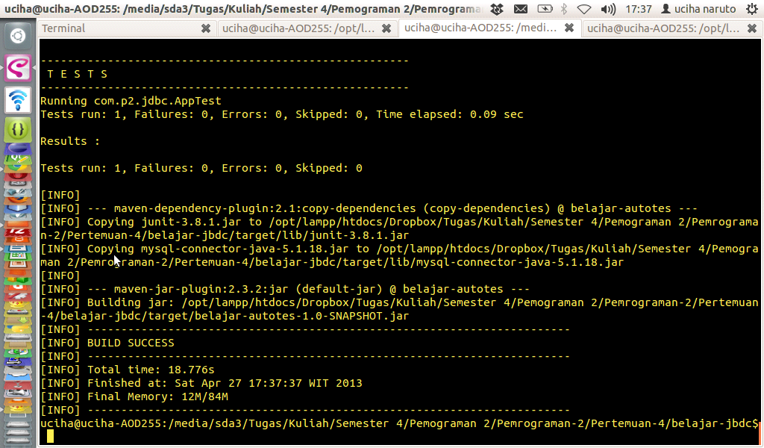

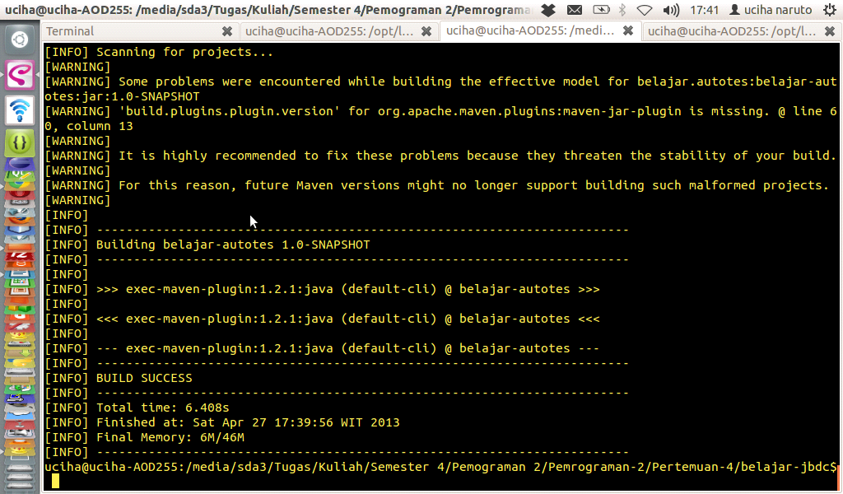

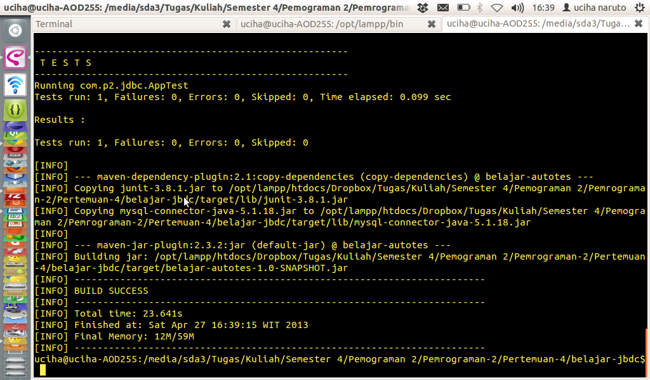

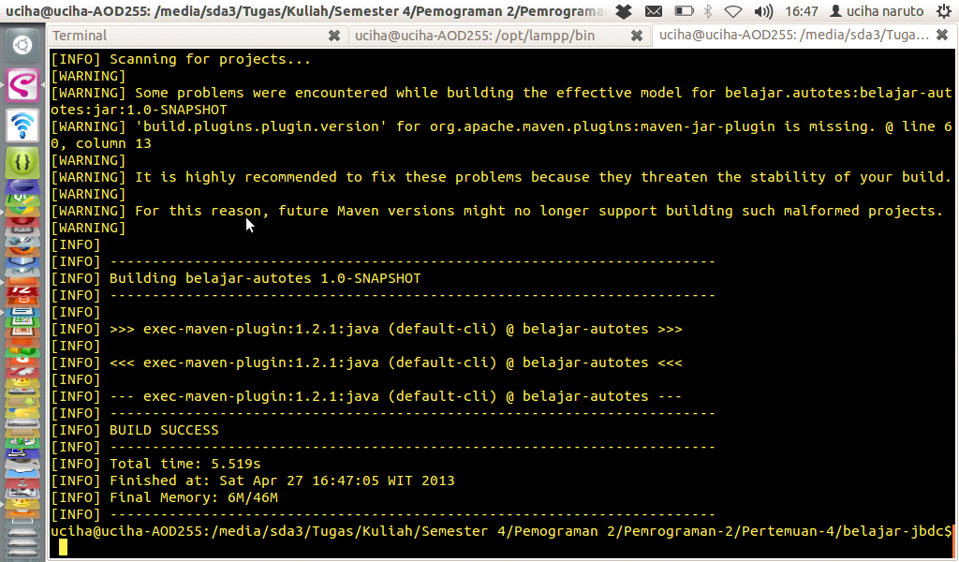

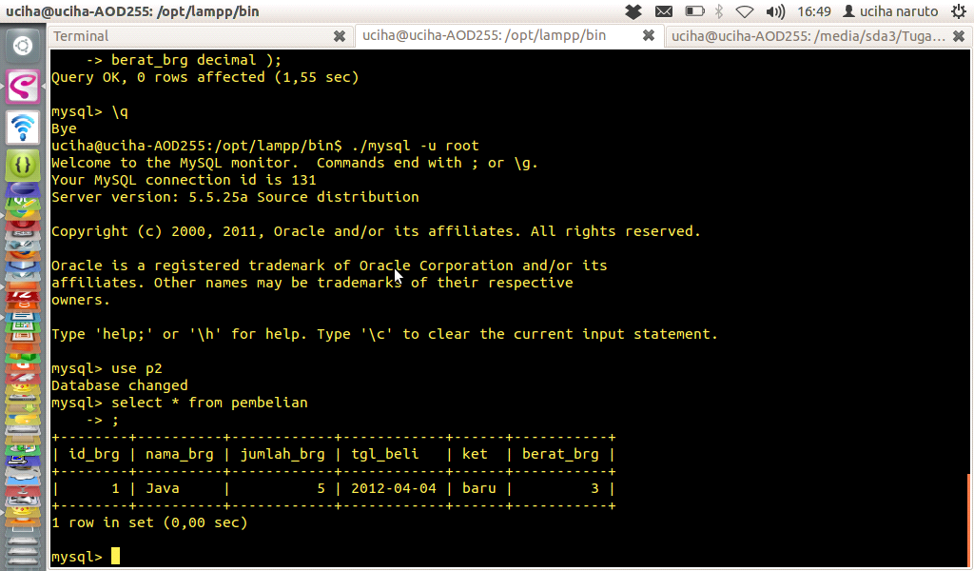

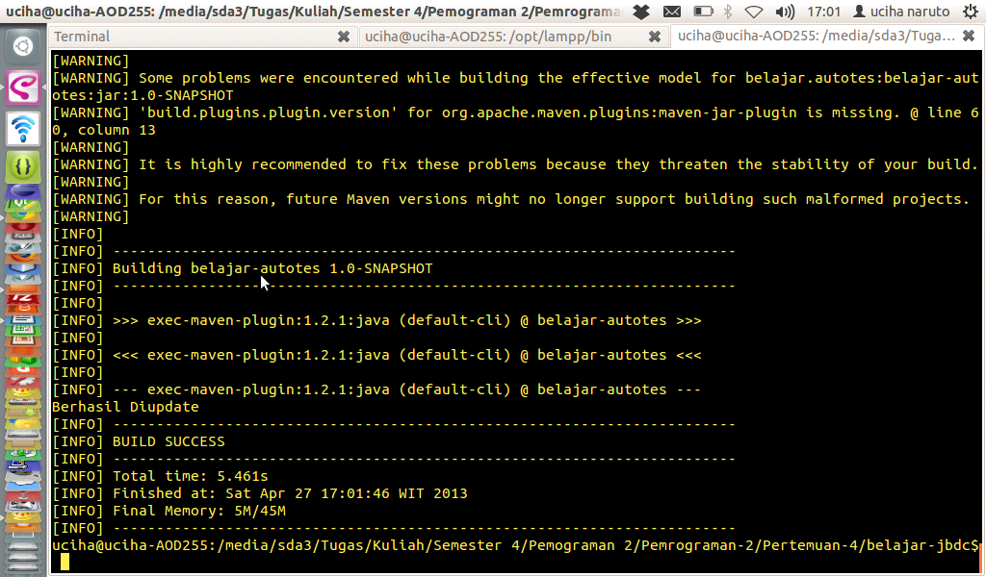

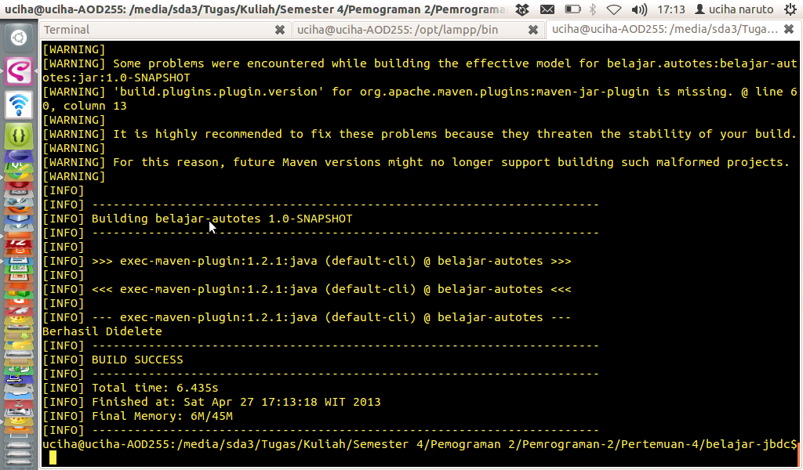

cek dimysql dengan mengetik “select * from pembelian;”

